AI Essentials: Tracking Student Completion using Course Insights

Course Insights – Overview
Developed by Penn State IT’s Data Empowered Learning team in collaboration with the Office of Faculty Affairs, Course Insights provides a holistic view of the student learning experience, empowering instructors to explore the relationships between course engagements and learner activity to outcomes in their courses, helping you shape pedagogical strategies, course administration, and out-of-class student support needs.

Accessing Course Insights
There are two methods by which an instructor may access Course Insights:
- Directly, via a website: https://insights.it.psu.edu/
- Within Canvas: By integrating Course Insights directly within Canvas, you have the ability to see data about your course and your students right where you are teaching and providing assessment feedback. Embed Course Insights into your Canvas course.

Viewing Aggregate AI Essentials Data
The Course Insights homepage features a new panel that displays the aggregate number of students registered for the course that have completed AI Essentials.

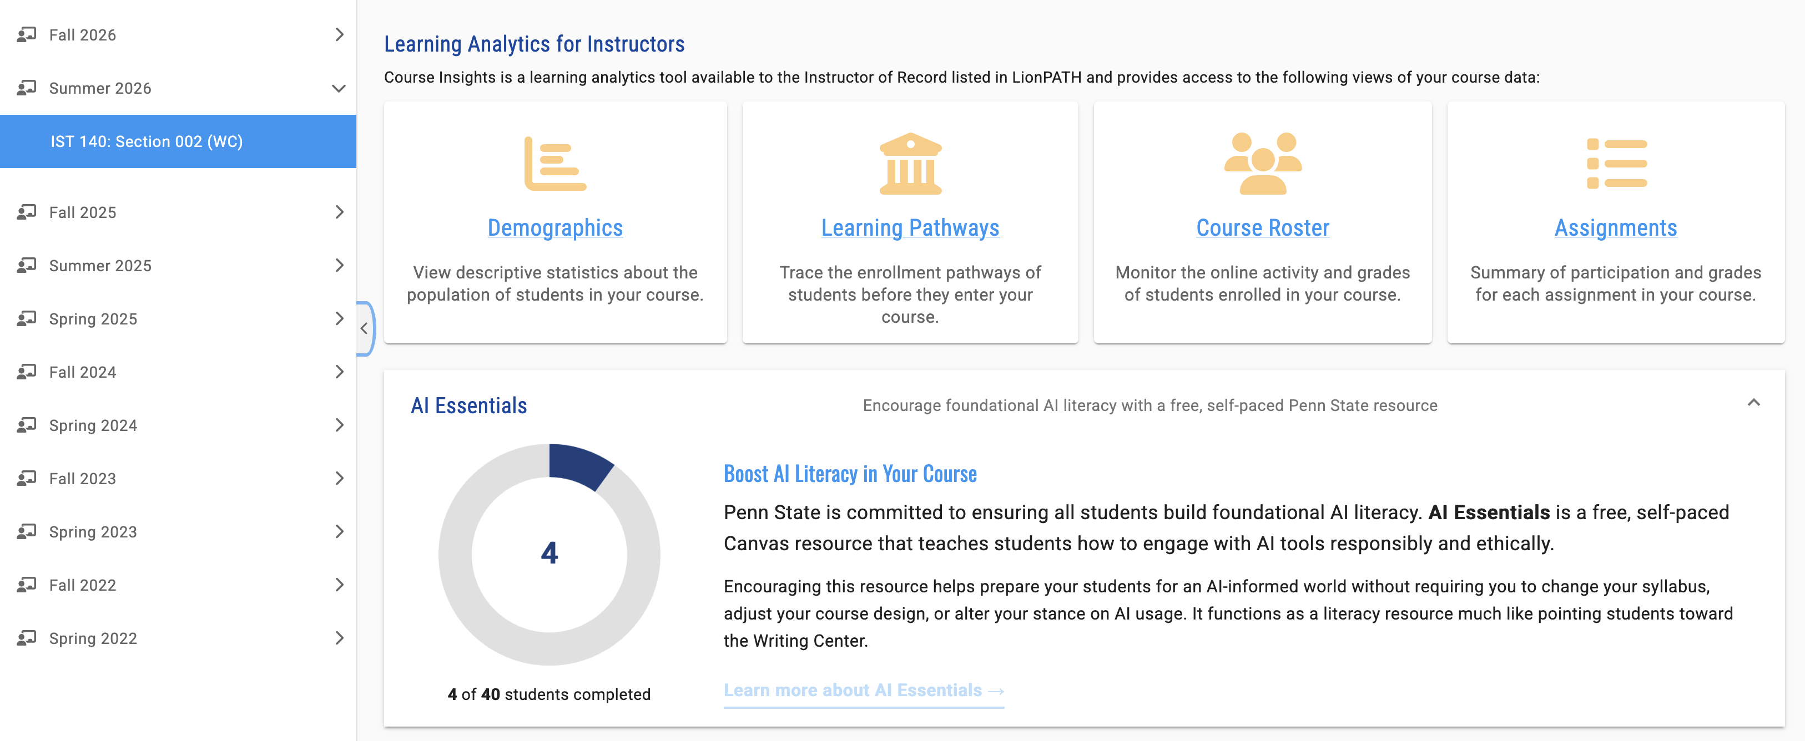

Accessing Student-specific AI Essentials Course Completion
Selecting a student from the Course Roster within Course Insights will take you to the student’s profile page. The student profile header features a new AI Essentials data point indicating whether “YES” a student has completed the AI Essentials course, or “NO” they have not.
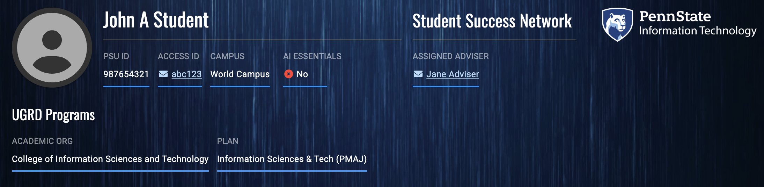

Download AI Essentials Course Completion and Gradebook Data
For those instructors looking for a course-level view of students who have completed the AI Essentials course, the Gradebook download in Course Insights’ Course Roster page can help.
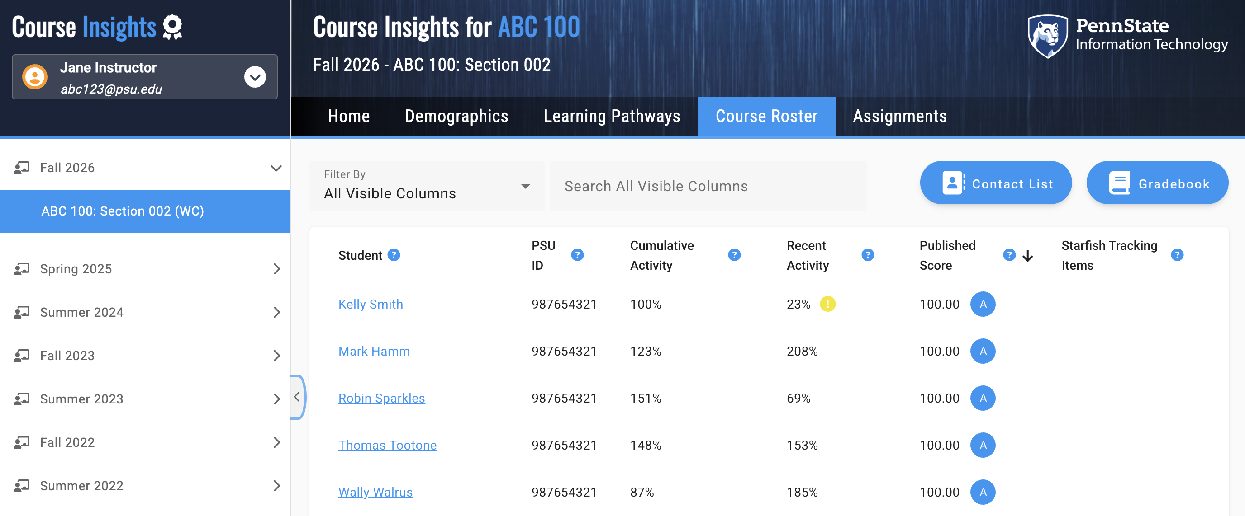
The Gradebook download provides instructors with an Excel spreadsheet of all current course grades appended with two additional columns related to whether a student has completed the AI Essentials course and on what date the course was successfully completed.

(NOTE: The AI Essentials course completion and completion date data are only available within the Course Insights gradebook download. This data will not appear automatically within the Canvas gradebook.)
